KATARINA CEHOVSKI

**Request 1**

List the last name, first name and employee number of all employees that have a last name starting with M.

**Expected**  
  
3 columns  
Last_Name, First_Name, Employee_No  
Marsh, Bob, 124  
…

**Query**

SELECT Last_Name, First_Name, Employee_No FROM Employees

WHERE Last_Name LIKE 'M%'

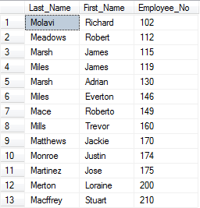

**Request 2**

List the last name, first name and employee number of all programmers who were hired on or before 11 Feburary 1994 sorted in descending order of last name.

**Expected**  
3 columns  
Last_Name, First_Name, Employee_No  
Cehovski, Katarina, 106  
…

**Query**

SELECT e.Last_Name, e.First_Name, e.Employee_No FROM Employees e

JOIN Jobs j ON j.Job_ID = e.Job_ID

WHERE j.Job_Title = 'Programmer' AND e.Hire_Date <= '1994-02-11'

ORDER BY e.Last_Name DESC

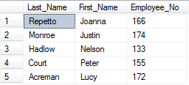

**Request 3**

List all the data for all jobs where the maximum salary is greater than 12000 sorted in ascending order of the maximum salary.

**Expected**

4 columns  
Job_ID, Job_Title, Min_Salary, Max_Salary  
IT_SOFT_DEV, Software Developer, 8000, 15000  
…  
  
**Query**

SELECT * FROM Jobs

WHERE Max_Salary > 12000

ORDER BY Max_Salary ASC

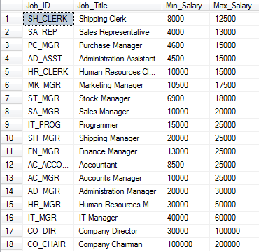

**Request 4**

List all the data for all jobs where the minimum salary is less than or equal to 4500 sorted in descending order of the minimum salary.

**Expected**

4 columns  
Job_ID, Job_Title, Min_Salary, Max_Salary  
AD_CLERK, Administration Clerk, 4500, 10000  
…  
  
**Query**

SELECT * FROM Jobs

WHERE Min_Salary <= 4500

ORDER BY Min_Salary DESC

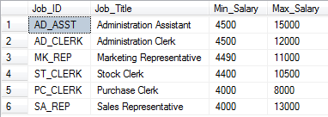

**Request 5**

List the department name, location, last name and salary of employees who work in location 1700 sorted in ascending order of department name.

**Expected**

4 columns  
Department_Name, Location_ID, Last_Name, Annual_Salary  
Accounting, 1700, Cehovski, 15000  
…  
  
**Query**

SELECT d.Department_Name, d.Location_ID, e.Last_Name, e.Annual_Salary

FROM Employees e

JOIN Departments d ON e.Department_No= d.Department_No

WHERE d.Location_ID =1700

ORDER BY Department_Name ASC

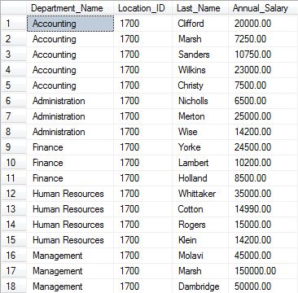

**Request 6**

Which jobs are found in the Marketing and Accounting departments?

**Expected**  
1 column  
Job_Title  
Accounts Clerk  
…

**Query**

SELECT DISTINCT j.Job_Title FROM Jobs j

JOIN Employees e ON j.Job_ID = e.Job_ID

JOIN Departments d ON d.Department_No =e.Department_No

WHERE d.Department_Name IN ('Marketing', 'Accounting')

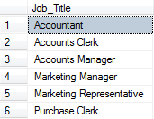

**Request 7**

Show the total salaries figure for one week displayed with no decimal places.

**Expected**  
1 column with number  
Total_Salary_Week  
25465  
  
**Query**  
  
SELECT CAST(SUM(Annual_Salary/52) AS INT) AS Total_Salary_Week FROM Employees



**Request 8**

Show the total number of jobs.

**Expected**  
  
1 column with number  
Total_Number_of_Jobs  
51  
  
**Query**  
  
SELECT COUNT(Job_ID) AS Total_Number_of_Jobs FROM Jobs



**Request 9**

List the department number, department name and the number of employees for each department that has less than 4 employees grouping by department number and department name.

**Expected**  
3 columns  
Department_No, Department_Name, Number_of_Employees  
50, IT, 2  
…  
  
**Query**SELECT d.Department_No, d.Department_Name, COUNT(*) AS Number_of_Employees

FROM Departments d JOIN Employees e

ON d.Department_No = e.Department_No

GROUP BY d.Department_Name, d.Department_No

HAVING COUNT(*) < 4

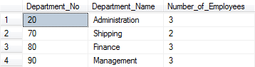

**Request 10**

List the department number, department name and the number of employees for the department that has the lowest number of employees using appropriate grouping.

**Expected**  
  
3 columns  
Department_No, Department_Name, Number_of_Employees  
50, IT, 2  
  
**Query**  
  
SELECT TOP 1 WITH TIES d.Department_No, d.Department_Name, COUNT(*) AS Number_of_Employees

From Departments d JOIN Employees e

ON d.Department_No = e.Department_No

GROUP BY d.Department_No, d.Department_Name

ORDER BY COUNT(*) ASC



**Request 11**

List the department number and name for all departments where no sales representatives work.

**Expected**  
  
2 columns  
Department_No, Department_Name  
50, IT  
…  
  
**Query**  
  
SELECT d.Department_No, d.Department_Name FROM Departments d

WHERE d.Department_No NOT IN

(

SELECT d.Department_No FROM Departments d

JOIN Employees e ON e.Department_No = d.Department_No

JOIN Jobs j ON e.Job_ID = j.Job_ID

WHERE j.Job_Title = 'Sales Representative'

)

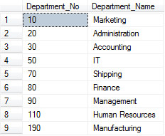

**Request 12**

Add the following new job IT_ASST, IT Assistant, 5000, 8000

**Expected**  
New job will be added.  
Job_ID: IT_ASST, Job_Title: IT Assistant, Min_Salary: 5000, Max_Salary: 8000  
  
**Query**  
  
INSERT INTO Jobs VALUES ('IT_ASST', 'IT Assistant', 5000, 8000)

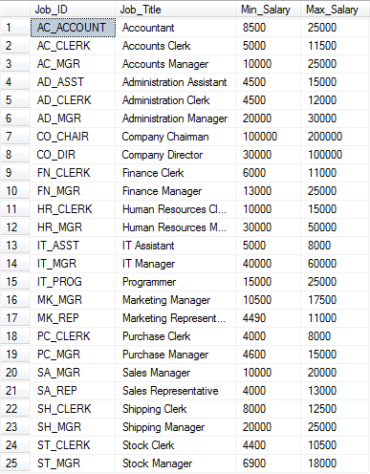

**Request 13**

Update all the maximum salaries for jobs with an increase of 2000

**Expected**  
All Max_Salary will be increased.  
Before: 27000, After: 29000  
  
**Query**  
  
UPDATE Jobs SET Max_Salary += 2000

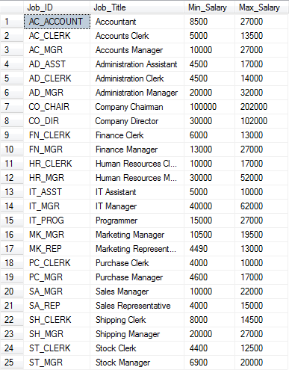

**Request 14**

List all the data for jobs sorted in descending order of job id.

**Expected**  
4 columns  
Job_ID, Job_Title, Min_Salary, Max_Salary  
IT_SOF_DEV, Software Developer, 8000, 15000  
…  
  
  
**Query**  
SELECT * FROM Jobs ORDER BY Job_ID DESC

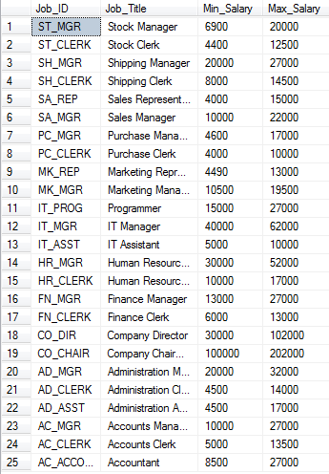

**Request 15**

a) The job history for employee number 125 is no longer required. Delete this record.

**Expected**  
Employee wit Emloyee_No 125 will no longer exist in table Job_History.  
  
**Query**  
  
DELETE FROM Job_History WHERE Employee_No = 125

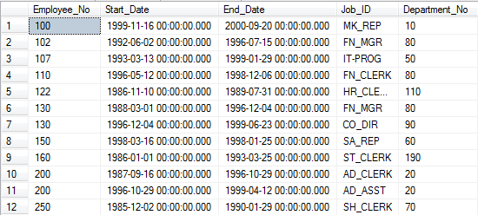

b) List all the data for job history sorted in descending order of employee number.

**Expected**  
5 columns  
Employee_No, Start_Date, End_Date, Job_ID, Department_No  
356, 12/12/2001, 05/04/2011, IT_SOFT_DEVE, 50  
…  
  
**Query**  
SELECT * FROM Job_History ORDER BY Employee_No DESC

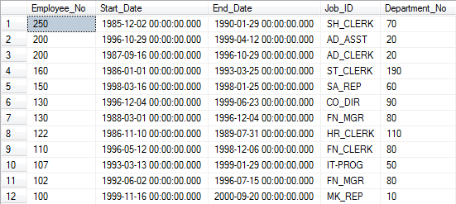

**Request 16**

Create a new view for clerks’s details only using all the fields from the employee table.

**Expected**  
New view table with name Clerks_Details will be created.  
  
  
**Query**  
  
CREATE VIEW Clerks_Details AS

(

SELECT * FROM Employees

WHERE Job_ID LIKE '%CLERK'

)

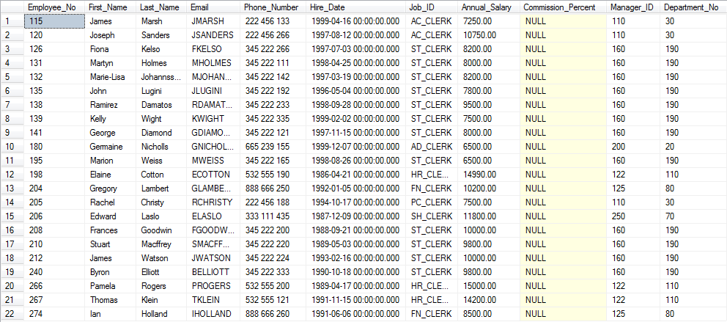

**Request 17**

Show all the fields and all the clerks using the view for clerks sorted in descending order of employee number.

**Expected**  
11 columns  
Employee_No, First_Name, Last_Name, Email, Phone_Number, Hire_Date, Job_ID, Annual_Salary, Commission_Percent, Manager_ID, Department_No  
  
102, Katarina, Cehovski, KCEHO, 456-421-123, 12/12/2012, ST_CLERK, 7600.00, 0.05, 120, 30  
…  
  
**Query**  
  
SELECT * FROM Clerks_Details

ORDER BY Employee_No DESC

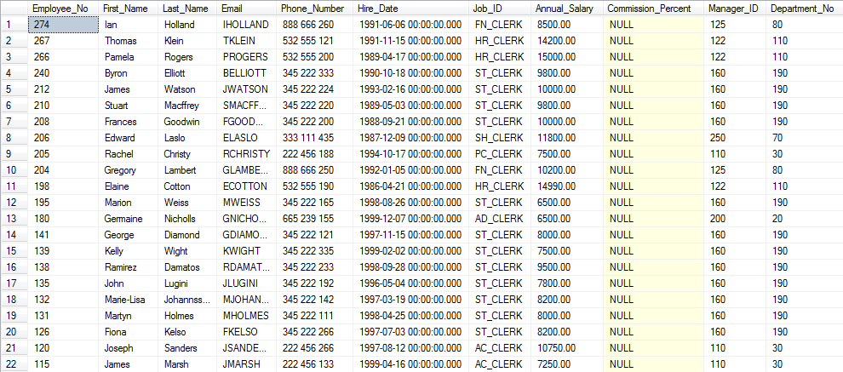

**Request 18**

Grant the authority to all other users to access the view for clecks for SELECT statements only.

**Expected**  
All users will be able to use only SELECT statement.  
  
**Query**GRANT SELECT ON Clerks_Details TO PUBLIC



**Request 19**

Create an index named LOC_POSTAL_CODE on the Postal Code in the locations table. Provide a printout showing that the index has been created.

**Expected**  
New index with name LOCATION_POSTAL_CODE will be added.  
  
**Query**  
  
CREATE INDEX LOCATION_POSTAL_CODE ON Locations (Postal_Code)

